Step 1: Adapter Installation

General Notes:
- The installer must determine the interrelationship of these parts with any other installed items.
- The approval basis for this conversion is by STC. Per 14 CFR 21.120 approval for installation on specific aircraft must be granted by Cygnet Aerospace Corp. and Major Repair and Alteration form 337 must be submitted in accordance with 14 CFR 43.9 Part 43 Appendix B.
- There are four versions of Cessna control column tubes with 2 unique adapters for each version for mounting either Beech or Cessna style control wheels. Use figures below to select the correct adapter version to use for your installation. See Adapter Selection, CA7600-ADAPT.

Remove Installed Components from Existing Control Wheel:

Remove existing electrical components, documenting wire connections for reinstallation into new wheel.

Adapters Installing Over the Control Column Tube, Versions A and B

¾” Version A

¾” diameter tube that plugs into the control wheel and secured with rivets.
Beech wheel uses CA60-524-75(Adapter, Small)
Cessna wheel uses CA7660-75 (Adapter, Small)

Adapter to control column attaching hardware:
- 2 AN3-14A bolts
- 4 NAS1149F0363P washers
  - Permissible to use thinner -316P/-332P washers or add up to 2 additional washers to adjust for grip length to maintain minimum 1.5 exposed threads.
- 2 MS21042-3 lock nuts, torque to 10-15 in-lbs
  - Permissible to use MS21044N3 lock nuts, torque to 20-25 in-lbs.

1-1/4” Version B

1-1/4” diameter tube that plugs into the control wheel and secured with rivets.
Beech wheel uses CA60-524-12 (Adapter, Large)
Cessna wheel uses CA7660-12 (Adapter, Large)

Adapter to control column attaching hardware:
- 2 AN3-20A bolts
- 4 NAS1149F0363P washers,
  - Permissible to use thinner -316P/-332P washers or add up to 2 additional washers to adjust for grip length to maintain minimum 1.5 exposed threads.
- 2 MS21042-3 lock nuts, torque to 10-15 in-lbs
  - Permissible to use MS21044N3 lock nuts, torque to 20-25 in-lbs

Remove Adapter from Control Tube

This is easiest if the control tubes are removed from the aircraft but may be accomplished in situ. Be sure to mark the tubes for respective pilot and copilot positions in addition to accurately marking the top of the tube when the ailerons are neutral. Re-install pilot and copilot control tubes after following mounting procedures below. Follow parts/service manual or any specific instructions by the manufacturer pertaining the installation or maintenance of these control column and related components. Drill out rivets using #1 drill max size. Use caution not to damage wiring internal to control column if done without removing control column.

Notes
- Adapter and control wheel installation should result in the new control wheel nominally in the same position. It is permissible to trim the control tubes to maintain the same nominal position of the control wheel. The distance between the forward adapter face and nearest point of contact during full forward travel is to be no less than 1/2 inch.
- Permissible to open internal bore diameter of adapter up to 0.010” to allow slip fit onto control tube.
- If adapter is loose in control tube, install with film of retaining compound such as LOCTITE 620 or similar per manufacturer’s directions.

Cessna Style Wheel

Slide adapters onto the control columns and orient the adapter such that the sides are vertical and horizontal and the new adapter holes align 90 degrees to old adapter holes. The control column aft end should be flush or within 1/4 inch forward of the control wheel mounting face. Use fine point marker and outline where holes are to be match drilled in column. Remove adapter and verify that a minimum ¼ inch of material is between old mounting holes and new mounting holes. Match drill control column holes to the adapter using #13 drill bit taking care not to damage wiring running inside the control tube. Deburr the holes and install with 2 AN3 bolts, nuts and washers. Verify bolts have minimum of one and a half threads showing after tightening. Attach new control wheels in accordance with Control Wheel Installation Instructions in step 2.
Cygnet (Beech) Style Wheel
Slide the adapters onto control column and orient the adapters such that the curved side is down. Use fine point marker and outline where holes are to be match drilled in column. Remove adapter and verify that a minimum ¼ inch of material is between old mounting holes and new mounting holes. Match drill control column holes to the adapter using #13 drill bit taking care not to damage wiring running inside the control tube. Deburr the holes and install with 2 AN3 bolts, nuts and washers. Verify bolts have minimum of one and a half threads showing after tightening. Attach new control wheels in accordance with Control Wheel Installation Instructions in step 2.

3 Hole Internal Mounting Adapters Versions C and D

Short Version C

Beech Wheel uses CA60-524-82(Adapter, Short)
Cessna Wheel uses CA7660-82 (Adapter, Short)

Adapter to control column attaching hardware:
- 3 MS24693-S270, screws torque to 20-25 in-lbs.

Long Version D

Beech Wheel uses CA60-524-77 (Adapter Long)
Cessna Wheel uses CA7660-77 (Adapter, Long)

Adapter to control column attaching hardware:
- 3 MS24693-S270, screws

This installation requires only the disassembly of the OEM control wheel/adapter and installation of the new adapter with the existing hardware.

Notes:
- Permissible to reduce diameter of adapter up to 0.010” to allow slip fit into control tube.
- Orient Beech Wheel adapters with curved side down.
- If adapter is loose in control tube, install with film of retaining compound such as LOCTITE 620 or similar per manufacturer’s directions.
- Radial screws are retained by locking threaded inserts and will be tight during installation.
- Attach new control wheels in accordance with Control Wheel Installation in step 2.

Step 2: Control Wheel Installation
Beech Style Control Wheel
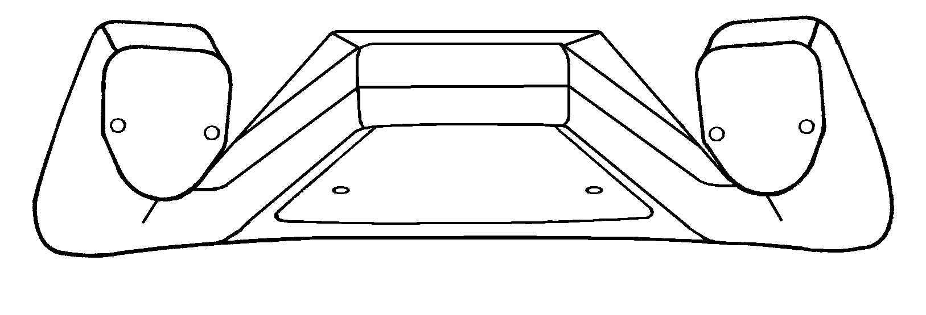
Beech style control wheels (CA60-524080-10, Alt PN: CA60-524080-17) to be installed with:
3ea. AN3-7A bolts
3ea. NAS1149F0363P washers
3ea. MS21044N3 nuts
Cessna Style Control Wheel
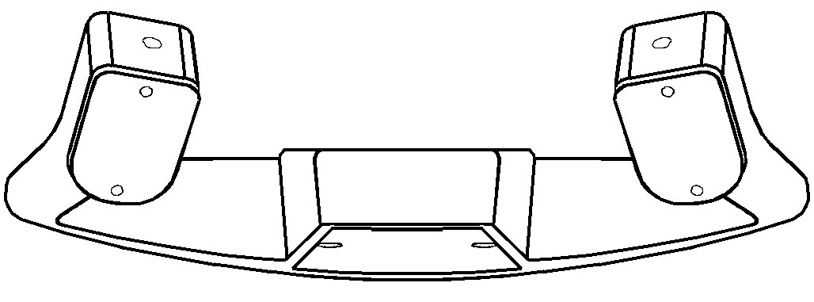
Cessna style control wheels (CA7650-10) to be installed with:
4ea. AN3-7A bolts
4ea. NAS1149F0363P washers
4ea. MS21044N3 nuts

Adapter mounting holes are slotted to compensate for slight variations of control system rigging and adapter installation to allow a wings level position of the control wheels with ailerons in the neutral position. Cessna style wheels have 4 mounting positions optimize ergonomics in different aircraft. Level the control wheel while using a straight edge on the bottom of the control wheels (or other convenient straight edge) and tighten the mounting bolts. Longer bolts and additional washers are permitted to adjust for casting variation or when installing an Adel Clamp under the nut or bolt. Bolt must have minimum 1.5 threads showing past the nut. Torque nuts to 20-25 in-lb.
Re-install existing control wheel mounted components (PTT, AP DISC, Electric Trim, etc.) per aircraft TCDS, STC and in accordance with Acceptable Methods and Practices AC43.13. Permissible to cut and form mounting features in thumb plates provided a minimum edge distance of 0.050 inches is maintained. Also permissible to drill control wheel casting in “trigger position” for PTT or other switches installed above the thumb rest feature. The control wheels castings are hollow to route wires to the thumb grips from the control wheel body. Bundled wires going through the grips should be lightly twisted.
Check bolt torque. Reinstall thumb and face plates. Verify proper control surface movement, full travel and freedom of movement of control wheel.
Typical installation shown below in Figures 1 and 2.
CA60-524080-10, Beech style control wheel with optional leather wrapping.
Switches mounted in thumb plate.
CA7650-10, Cessna style control wheel with optional leather wrapping.
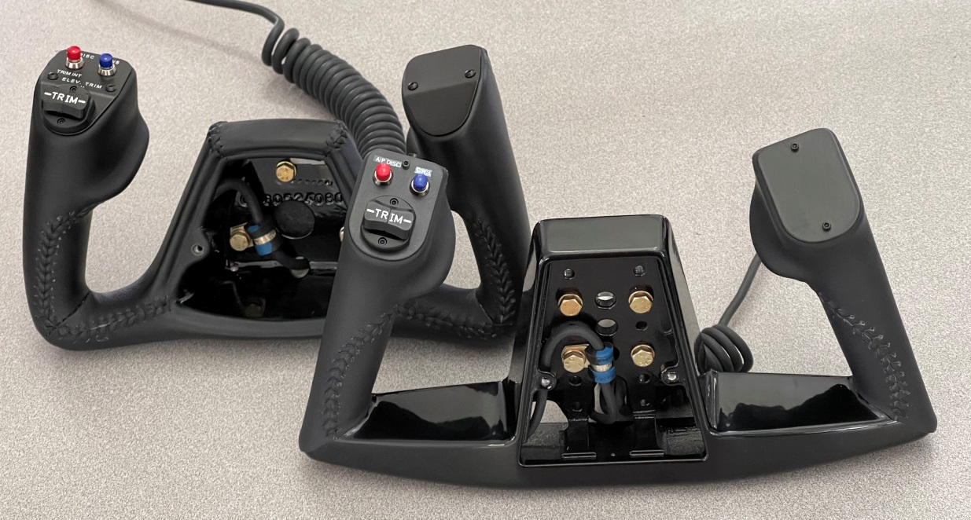
Coil cord can be routed to thumb plate inside the control wheel casting.
Adel Clamp under mounting bolt head to strain relieve coil cord.

Figure 1: Front view of Beech and Cessna style control wheels mounted to adapters. Switches have been mounted in both wheels as typically done when installing Garmin GFC 500/600 auto pilots. The control wheels have provision to have the coil cord exit through the bottom of the wheel or through the back into the control column as needed. In both cases, the cable should be strain relieved. Face plates have been removed for clarity.

PTT switch installed in trigger position.
CA60-524080-82 short adapter for control columns with 3 radial holes.
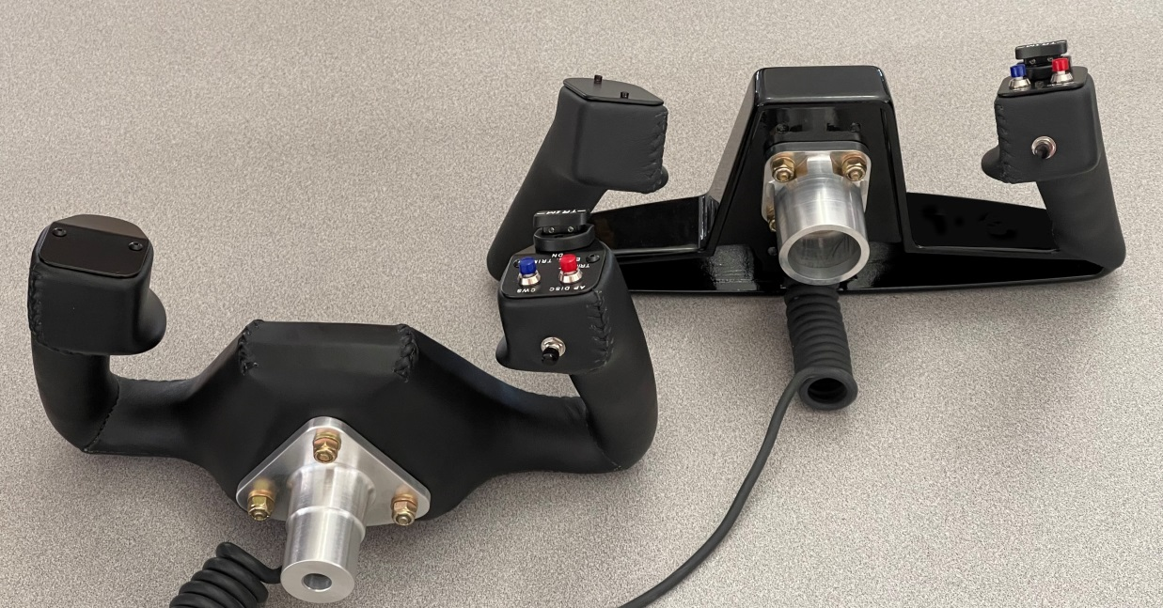
Figure 2: Rear view of Beech and Cessna style control wheels. PTT switches have been installed in trigger position. The adapters are shown with paint omitted for clarity and no control columns to adapter bolt holes have been drilled.
CA7660-12 adapter for 1.25” diameter control tube and Cessna style wheel.

